NURUDEEN ABDULSALAAM

[olaitansalaam2012@gmail.com](mailto:olaitansalaam2012@gmail.com)

DAY 2: SET-UP

1. How to use Chart Gpt.

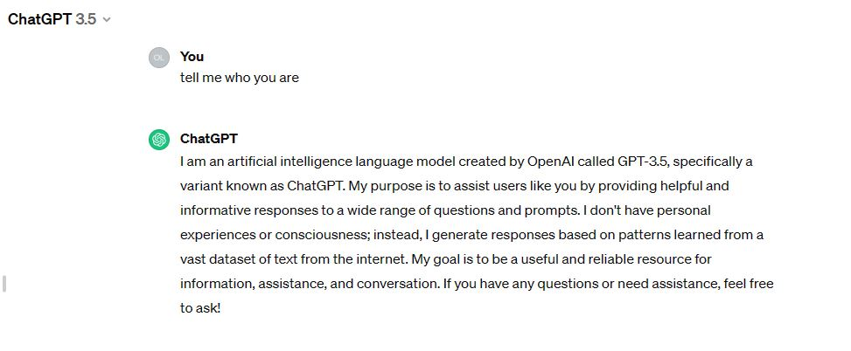

1. How to install git

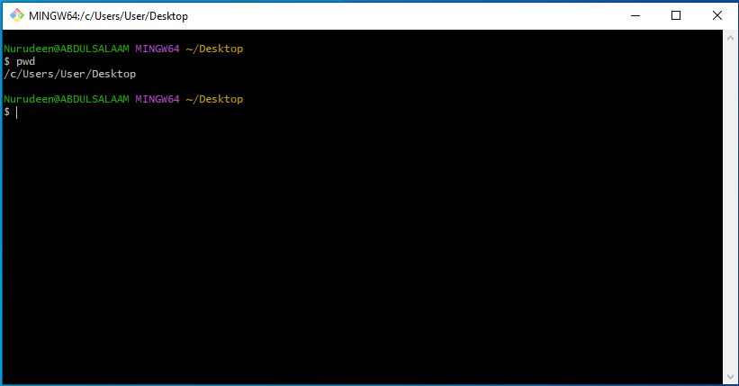

1. Getting started with Github

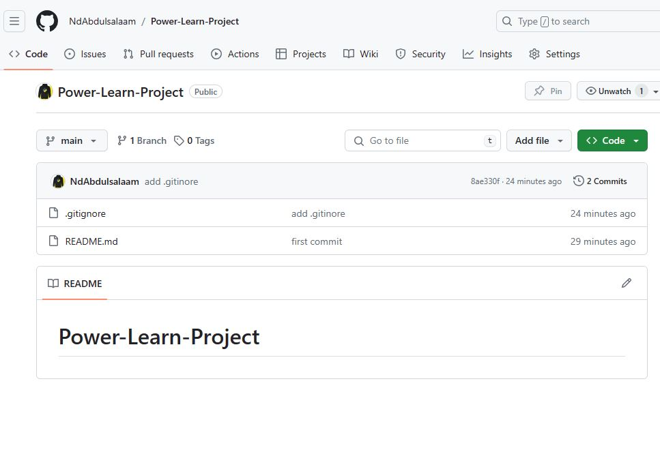

1. CLI Commands.

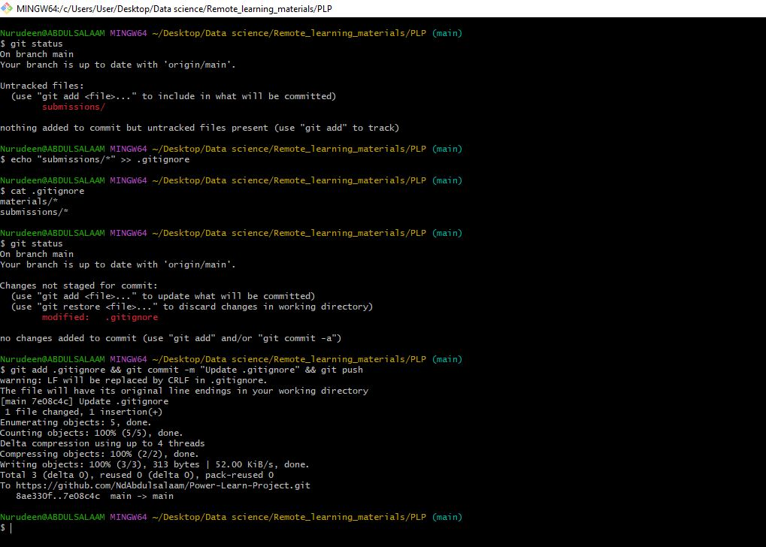

1. Python setup

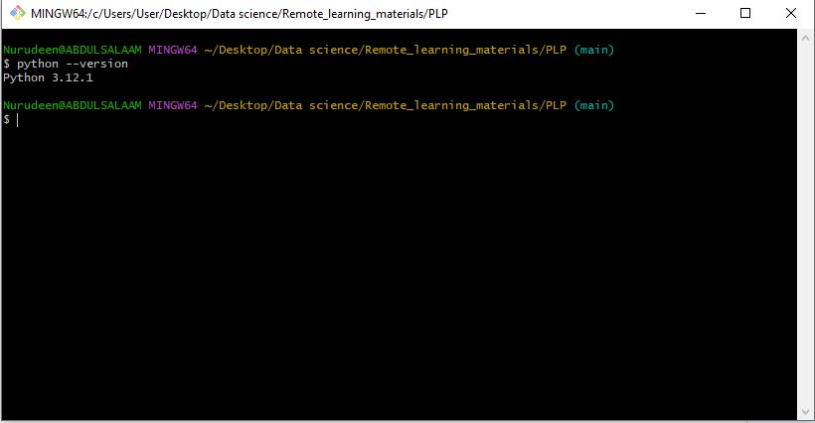

1. Visual Studio Installation. & Adding Extensions.

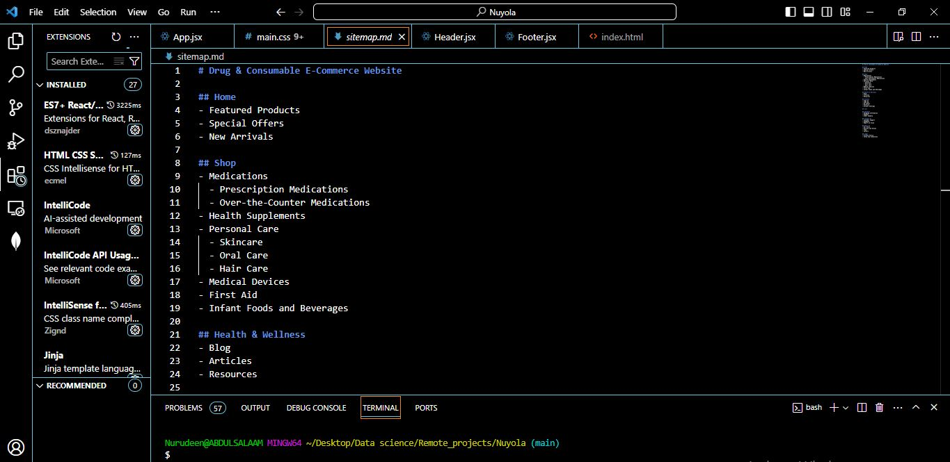

1. Dart set up

